**An Analysis on Mark-18A Target Irradiation History and Inventory of Plutonium and Heavy Curium**

Benjamin Austin, W. Cade Brinkley, Jennifer Jeffcoat, Jacob Weinberg, Benjamin Beeler

**Abstract**

From 1969 to 1979, the Savannah River Site (SRS) produced and managed heavy isotopes as directed by the DOE. This was accomplished by exposing 86 highly enriched Pu-242 Mk-18A Outer Housing (OH) targets to high neutron fluxes in the K-Reactor with the initial intent to produce Cf-252 [1]. Although this directive was abandoned just over a year later, the plutonium targets continued their exposure in an effort to produce Pu-244 for the duration of the decade. After decommissioning, 21 of the targets were transferred to Oak Ridge National Laboratory (ORNL) to extract the accumulated Cf-252. The remaining 65 Mk-18A targets remained in water basin storage located at SRS. The purpose of this study is to model the irradiation history of the core and the decay of isotopes to approximate the inventory of each individual target.

# 

**Introduction** **3**

**Computational Methods** **5**

**SCALE** **8**

**Results** **9**

**Discussion** **17**

**Conclusion** **21**

**Acknowledgments** **22**

**Work Cited** **23**

**Appendix A (Core Placement for each cycle x, y)** **25**

**Appendix B (Irradiation History)** **28**

**Appendix C (Cumulative Results Projection for January 1, 2025 [g])** **30**

# 

# Introduction

The high flux Californium I irradiation campaign began August 11, 1969 and ended November 8, 1970. During this time, 86 Mk-18A targets with high enriched Pu-242 were exposed to a high neutron flux in an effort to produce Cf-252 [1]. Californium is a synthetic radioisotope produced in reactors via multiple neutron capture reactions, which is a highly sought-after neutron source. With a half-life of 2.6 years and a 3% natural fission decay rate, it has uses in medicine, reactor startup [2], metal detectors [3], etc. There are only 2.625 grams of Cf-252 produced annually worldwide [4]. Figure 1 shows the rationality behind using enriched Pu-242 instead of natural uranium for the campaign, in that the number of neutrons required to produce a single atom of Cf-252 is greatly reduced.

|  |
| --- |
|  |
| *Figure 1: Production chain of Californium 252 from Uranium 238 (Public Domain).* |

Between 1972 and 1973, 21 of the 86 Mark 18-A targets were processed to recover Cf-252, heavy curium, and plutonium. The extraction of these isotopes was applied to industrial applications and the discovery of new transactinides. Savannah River Site (SRS) currently houses the majority of the world’s heavy curium and plutonium in the remaining 65 targets. The supply of these isotopes from the 21 processed targets is expected to deplete by 2030 [1].

In 2012, SRS was appointed to address the disposal or recovery of the remaining 65 Mark 18-A targets. This study assessed seven alternatives for the disposition of the Mark-18A: five unique choices for recuperation of the materials for later use, a fractional recuperation choice, and a possibility for disposing of the Mark-18A material as waste. The investigation recommended that the targets be processed to recover the essential Pu-244 and heavy curium and move the materials to ORNL for capacity and future advantageous use. [5]

In this work the contents of the remaining 65 targets will be analyzed by utilizing a computational method to determine the mass concentration of the Pu 244 and heavy curium. The results will be used to elucidate which assemblies should be processed first by SRS to recover Pu 244 and heavy curium. As the specifications of the Mark 18A targets are classified, the computational model is made with calculated and assumed variables, such as flux profile, enrichment, and geometric assumptions. As such, this study is not meant to provide exact quantitative predictions of isotopic concentrations. However, the qualitative assessments of isotopic concentrations will be utilized by SRS to determine processing schedule and priority for the various target assemblies

# Computational Methods

The K-reactor core consists of a hexagonal lattice of annular driver assemblies as shown in figure 2 [6]. It is cooled/moderated with heavy water and its 6 coolant loops enable high neutron fluxes by dissipating approximately 18 MW per assembly of thermal energy [7]; ideal for isotope production.

|  |
| --- |
|  |
| *Figure 2: Face Map of the K-reactor located at SRS [3].* |

Many design specifics of the K-reactor are classified. The enrichment of the drivers, geometry and location of the 90 assemblies used [8], peaking factors, fuel to moderator ratio, and other parameters that are necessary when modeling a full reactor core can only be known to a best estimate using declassified material. Because of this, irradiation histories were modeled one assembly at a time in an effort to mitigate any sources of error that may propagate throughout the model. A consequence of this method is the need to develop a flux distribution function. This was achieved assuming a sinusoidal radial distribution, a radial peaking factor of 1.35, and equations 1 and 2:

|  |  |
| --- | --- |
| $$q(r)=q_{0 }cos(r)$$ | (1) |
| $$F_{r}=\frac{q_{0}}{\frac{1}{πR^{2}}\int_{0}^{R}{}2πrq(r) dr}$$ | (2) |

Since the dimensions of the core were unknown and the placement of the targets was provided in cartesian coordinates, the x and y indices (Appendix A) were utilized (and normalized to $π/2$) resulting in equation 1 becoming:

|  |  |
| --- | --- |
| $$q(x,y)=q_{0}cos(\sqrt{x^{2}+y^{2}})$$ | (3) |

and equation 2 becoming:

|  |  |
| --- | --- |
| $$F_{x,y}=\frac{q_{0}}{\frac{1}{π}\int_{-2}^{1}{}\int_{-\sqrt{1-x^{2}}}^{\sqrt{1-x^{2}}}{}q(x,y) dy dx}$$ | (4) |

Figure 3 shows the general shape of the flux profile using this method. This distribution function was utilized to assign power levels to each assembly in each cycle for the duration of the irradiation time.

|  |
| --- |
|  |
| *Figure 3: Assumed shape of the K-Reactor’s flux profile with exaggerated amplitude for visualization.* |

|  |
| --- |
|  |
| *Figure 4: Sketches of MK-14 and 16 Tubes that were used in later irradiation cycles after the Cf production campaign [9]* |

The model assumes that each assembly consists of three inner concentric uranium-aluminum alloy annuli that are 6 ft tall, referred to as the drivers (as seen in figure 4), and a single plutonium-aluminum alloy annulus, referred to as the target, around the middle four feet of the drivers [10]. The drivers are assumed to share dimensions with 2, 2.5, and 3-inch schedule 10 aluminum pipe while the target is assumed to share the dimensions of a 3.5-inch schedule 40 aluminum pipe. Additionally, the initial amounts of the activated isotopes in the target and the amount of fuel in the three driver rings throughout their lifetimes is known. This is used to find the isotopic density of the relevant material with the known geometries as shown in equation 5.

|  |  |
| --- | --- |
| $$ρ_{x}=\frac{m_{x}}{V_{x}}$$ | (5) |

The Mk-18A drivers used in the first irradiation cycle contained a nominal amount of 180 grams of U-235. The subsequent cycles utilized Mk-14 (1500 g/assembly U-235), Mk-16 (3000 g/assembly U-235), and Mk-22 (3400 g/assembly U-235) drivers [11].

# SCALE

SCALE is a code system developed by the reactor and nuclear systems division of ORNL. SCALE is widely used for a variety of purposes including nuclear safety analysis, radiation shielding, reactor physics, and activation analysis. Some main computational modules are three Monte Carlo transport solvers and three deterministic solvers. SCALE also contains multiple data libraries to support these solving capabilities. SCALE was developed to combine each of these capabilities into a robust, easy to use platform [12].

SCALE’s t-depl depletion sequence within the TRITON module is used for the model. Compositions for each material were defined using densities and isotopic percentages of the three materials: U-Al drivers, the Pu target, and the heavy water moderator. A geometry was then defined in a 2-dimensional mesh. To account for the different assemblies used throughout the irradiation, a timetable block was used to change the uranium densities in the driver annuli. This approximation accounts for the different number of driver annuli present in the MK-22 assemblies (figure 5) used during some cycles as well as isotopic amounts were all conserved. The irradiation itself was defined using a burndata block consisting of the dissipated assembly power and the number of days exposed.

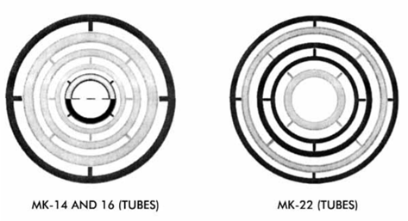

*Figure 5: Sketch of MK-22 Tubes that were used in later irradiation cycles after the Cf production campaign [2]*

# Results

A unique input file was generated for each of the sixty-five assemblies, each with a unique flux history. The masses of specific isotopes were monitored over the lifetime of operation in-reactor, as well as after the shut-down period of the K-reactor. The assemblies were exposed for about 10 years. The shut-down period was modeled using two points of time: the first when the reactor shut down, and the second as 15,000 days (41.1 years) after that event. After production, depletion, and decay, the mass concentrations of key isotopes were analyzed, including Pu-244, Cm-242, Cm-243, Cm-244, Cm-245, Cm-246, Cm-247, Cm-248, and Cm-250.

As the primary objective of this study was to determine which assemblies produced the most Pu-244 following their initial exposure, the first isotope investigated was Pu-244. The overall trend of the Pu-244 concentration as a function of time is shown in figure 5.

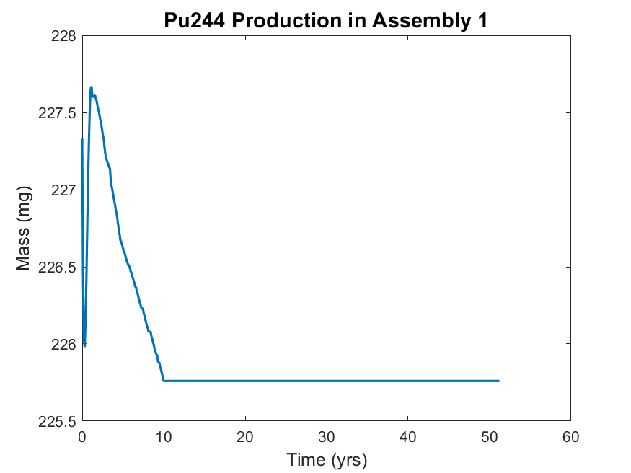

*Figure 6. The production of Pu-244 in assembly 1. The assembly was irradiated for approximately 10 years before being put into storage for roughly 40 years.*

Initially, there were 227.3 mg of Pu-244 in the assembly. In the first few months of operation, the plutonium concentration in assembly 1 decreased before rising to a maximum of 227.7 mg. This maximum occurs 1.14 yrs into the irradiation history. The Pu concentration subsequently decreased until the K-reactor shut down. Expectedly, the SCALE simulation calculated no change in the Pu-244 concentration following the K-reactor shutdown due to the long lasting half-life of Pu-244 (T1/2= 80 million years). To better understand how the plutonium concentration varies between the assemblies, the assemblies with the most and least Pu-244 during reactor operation and shutdown are tabulated below.

|  |  |  |  |
| --- | --- | --- | --- |
| **Most Remaining** | | **Least Remaining** | |
| **Assembly No.** | **Mass (mg)** | **Assembly No.** | **Mass (mg)** |
| 46 | 226.6 | 36 | 224.9 |

*Table 1. Tabulated values for the Pu-244 masses in the assemblies that currently contain the most and least remaining Pu-244 by mass.*

At the end of the simulation, assembly 46 had 226.6 mg of Pu-244 and assembly 36 had 224.9 mg of Pu-244. To better understand the trends in plutonium production in the assemblies, the production trends for both assembly 46 and 36 are visualized below in figure 6.

It is apparent that regardless of the final inventory in the assemblies, the Pu-244 concentration in assembly 36 and 46 reached their respective maximums approximately 1 year into the irradiation history (227.66 mg and 227.67 mg, respectively). Following the maximums, the Pu-244 concentrations decreased to their respective saturation levels. The mass concentration in assembly 36 decreased at a faster rate compared to assembly 46; therefore, assembly 36 possesses the smallest amount of Pu-244.

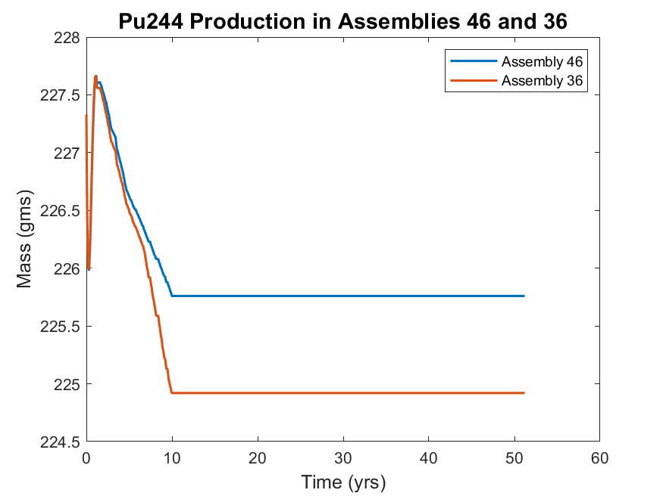

*Figure 7. Plutonium production during reactor operation and shutdown in assembly 46 and 36. The reactor was shut down at approximately t = 10 yrs.*

The factors leading to the production of Pu-244 are investigated by considering the production of Cf-252, a strong neutron source [13]. Assembly 46, which was found to have the highest amount of Pu-244 at the simulation end, was found to produce the least amount of Cf-252 (among all assemblies). Contrarily, assembly 36 produced the least amount of Pu-244 and produced the highest amount of Cf-252 (among all assemblies). Further, leading up to the reactor shut down the amount of Cf-252 in assembly 36 increased by approximately 0.15 mg while there was no significant increase in Cf-252 in assembly 46. The production and decay of Cf-252 in assembly 36 and 46 can be seen below if figure 7. As expected, all of the Cf-252 decayed away by the simulation end.

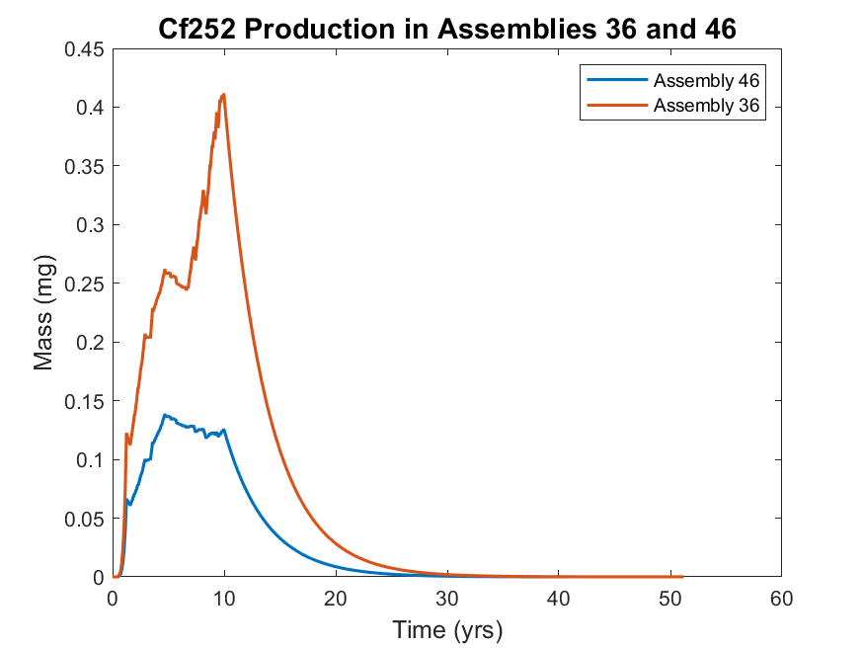

*Figure 8. Production of Cf-252 in assemblies 36 and 46. There are local maximums after roughly 5 years and 10 years. The remaining Cf-252 at shutdown quickly decays away (T1/2 = 2.6 yrs).*

This comparison between the production of Cf-252 and Pu-244 brings up the question of why assemblies that contained the most Cf-252 currently contain the least Pu-244. The irradiation history for each assembly is unique and therefore, could reveal underlying trends in the simulations. For each assembly, an average power was calculated and plotted with final Pu-244 inventory mass on a dual y-axis plot (figure 9). It can be seen that in most assemblies where average power is low, Pu-244 mass is high. There are also groupings of assemblies where power is generally high (approximately assemblies 36 - 44) and low (approximately assemblies 49 - 62 and 7 - 15). The non-uniformity between the average power and mass indicates that there are more factors that influence isotope production. This figure also reveals that the final inventory in assembly 39 is the same as assembly 36.

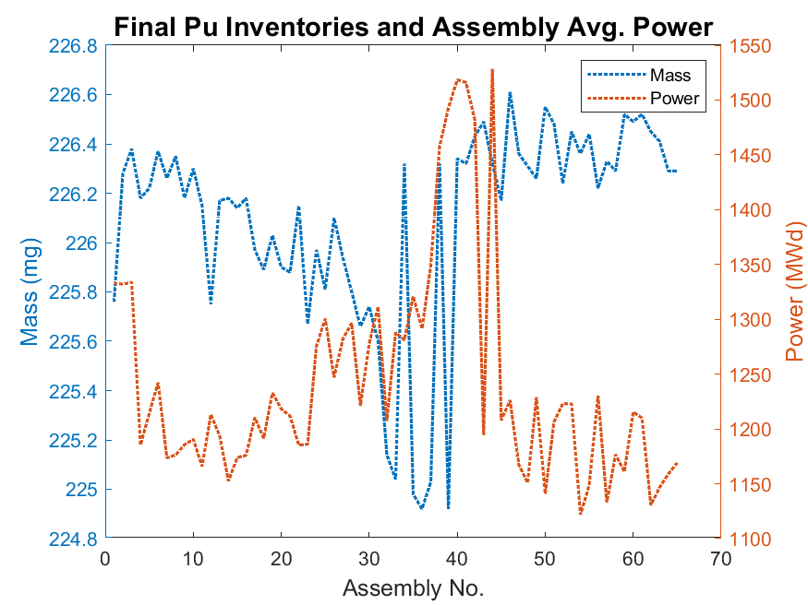

*Figure 9. The final Pu-244 inventory and average power plotted for each assembly. To make the relationship between average assembly power, mass, and assembly no. easier to visualize, a dotted line was used to connect the data points.*

Curium was another element that was of interest to SRS, specifically heavy curium (Cm-246, Cm-247, Cm-248).

The isotopes of Curium that were found to be high mass concentrations were Cm-244, Cm-245, and Cm-246. The masses of Cm-250 are significantly smaller than the other isotopes listed and are not included in the following analysis. The assembly that has the highest heavy curium inventory is assembly 39, while assembly 46 produced the least amount of heavy curium. As previously shown, assembly 46 was also found to contain the most Pu-244. Figures 10 and 11 show the production of the heavy curium isotopes. The assemblies that currently possess the least and most Cm are tabulated below.

|  |  |  |  |  |
| --- | --- | --- | --- | --- |
|  | **Most Remaining** | | **Least Remaining** | |
| **Isotope** | **Assembly** | **Mass (mg)** | **Assembly** | **Mass (mg)** |
| **Cm-242** | 14 | 0.0031 | 36 | 0.0014 |
| **Cm-243** | 32 | 0.2376 | 42 | 0.1503 |
| **Cm-244** | 57 | 5458 | 30 | 5319 |
| **Cm-245** | 56 | 949.0 | 39 | 930.3 |
| **Cm-246\*** | 39 | 3460 | 46 | 2613 |
| **Cm-247\*** | 39 | 100.2 | 46 | 67.30 |
| **Cm-248\*** | 39 | 56.23 | 46 | 29.55 |
| **Cm-250** | 36 | 1.128 E-5 | 46 | 4.940 E-6 |

*Table 2.* *Tabulated inventories of all tracked curium isotopes. Assembly 39 contained the most heavy curium and assembly 46 contained the least amount of heavy curium.*

*(* Isotopes considered part of heavy curium)*

Figure 8 compares the production of Cm-246 in assemblies 39 and 46. The concentration of Cm-246 in these assemblies diverged approximately one year into the irradiation history. The mass concentrations remained unchanged following the shutdown of the reactor. Of the three heavy curium isotopes, Cm-246 contributes the most (approximately 96% by mass). The difference in the final masses is 847 mg and there is an approximate 28% difference between the masses in assembly 39 and 46.

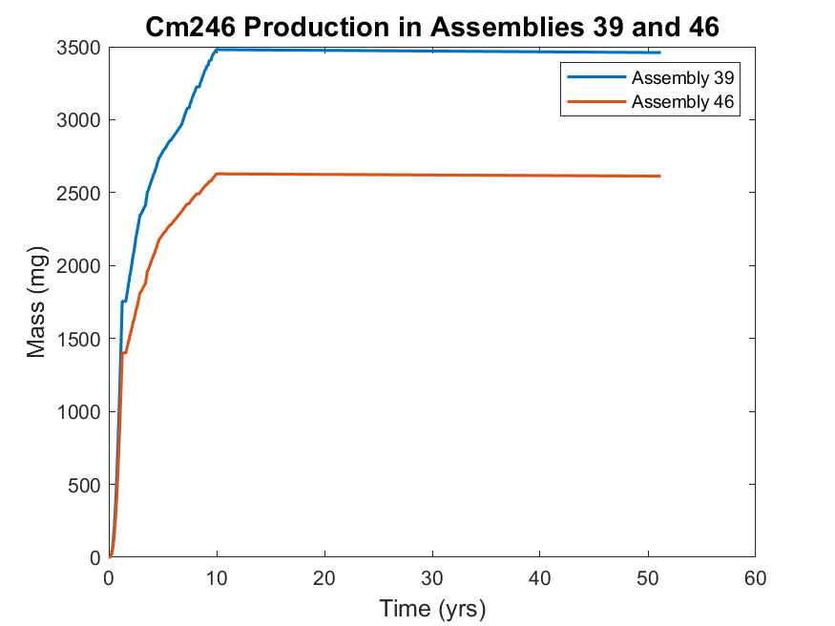

*Figure 10. Cm-246 production in assemblies 39 and 46. Assembly 39 produced the most Cm-246 and assembly 46 produced the least amount of Cm-246. There is no calculated change in the mass concentration after reactor shutdown at 10 yrs.*

Figure 11 shows the final inventories of Cm-247 and Cm-248 in assemblies 39 and 46. Assembly 39 possesses the largest amount of Cm-247 and Cm-248 among all assemblies and assembly 46 possesses the least among all assemblies. The contribution of Cm-247 and Cm-248 to heavy curium is approximately 4% by mass and thus has a smaller influence on the total inventory of the heavy curium at SRS. There is a difference of 39% of Cm-247 and 62% of Cm-248 between the masses in assembly 39 and 46. So, the relative difference of Cm-247 and Cm-248 in assemblies 39 and 46 is much higher than Cm-246 (28%). Further, a 39% loss of Cm-247 and 62% loss of Cm-248 will only decrease the amount of heavy curium by 59.6 mg.

It can be seen that assembly 36 and 39 had the least amount of Pu-244 and the most amount of heavy curium. Assembly 46 contained the most Pu-244 and least heavy curium.

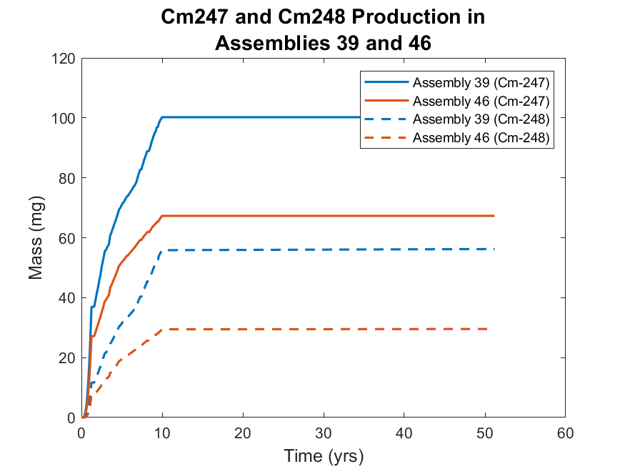

*Figure 11. Cm-247 production in assemblies 39 and 46. Assembly 39 produced the most Cm-247 and Cm-248 and assembly 46 produced the least amount of Cm-247 and Cm-248. There is no calculated change in the mass concentration after reactor shutdown at 10 yrs.*

# Discussion

Including all 65 assemblies, a total of 196.8 g of heavy curium was produced. Of which, assembly 39 produced 3616 mg (1.84 % of total heavy curium) and assembly 46 produced 2710 mg (1.37 %). Thus, while there is a noticeable difference in the final inventories of the individual assemblies, the actual contribution to the total heavy curium inventory appears to be similar. The average amount of heavy curium per assembly was 3026.9 mg with a standard deviation of 229.7 mg. The median contribution to the total heavy curium mass was 1.51 % with an interquartile range of 0.13 %. The distribution of heavy curium among the assemblies is shown below in a histogram.

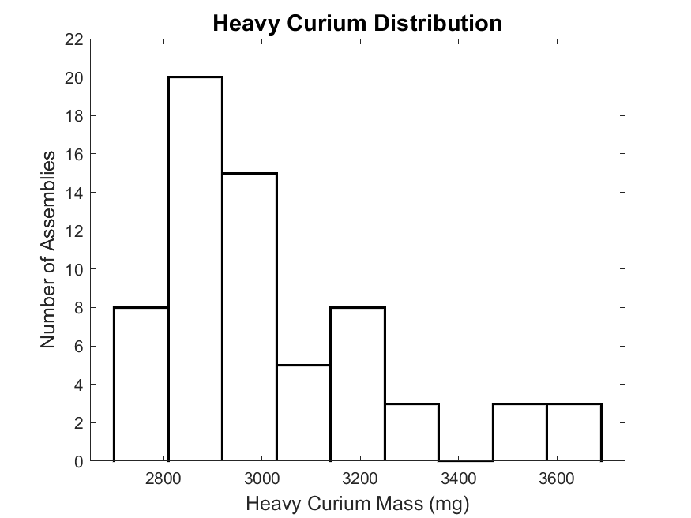

*Figure 12. Histogram of the assembly contribution to total heavy curium mass. The distribution is skewed right with some outliers existing on the upper-end of the distribution.*

This histogram shows; however, that most of the assemblies produced between 2880 mg and 3150 mg of heavy curium (interquartile range is 269.6 mg). While the range of the data is small (0.91 g), the distribution shows that production was not uniform among all assemblies. A minority of assemblies possess a statistically large amount of heavy curium. To further investigate this, a statistical summary of the individual isotopes of heavy curium and Pu-244 are tabulated below.

|  |  |  |  |  |  |
| --- | --- | --- | --- | --- | --- |
|  | Mean Inventory (mg) | Median Inventory (mg) | Min. Inventory (mg) | Max. Inventory (mg) | Standard Deviation (mg) |
| Pu-244 | 226.1 | 226.2 | 224.9 | 226.6 | 0.4226 |
| Cm-246 | 2910.7 | 2851.9 | 2613 | 3460 | 214.8 |
| Cm-247 | 78.39 | 75.98 | 67.30 | 100.2 | 8.27 |
| Cm-248 | 37.81 | 35.75 | 29.55 | 56.22 | 6.67 |

*Table 3. Statistical summary for Pu-244, Cm-246, Cm-247, and Cm-248. The median Pu-244 is within one σ of its maximum while all other median values are at least 2 σ from their respective maximums.*

It was previously indicated that assemblies with small amounts of heavy curium would contain large amounts of Pu-244. Further, a link between the maximum amount of Cf-252 produced and Pu-244 emphasizes that there are underlying factors in this relationship. Figure 12 visualizes the 65 assemblies (in no geographically significant order) and their respective current concentrations of Pu-244, heavy curium, Cm-245, Cf-252 (maximum produced), along with the average power applied to each assembly. The trends observed show that a statistically-large amount of Pu-244 corresponds to a statistically-small amount of heavy curium and Cf-252 (figures 13a, 13b, 13d). For assemblies where average power was high, Pu-244 and Cm-245 production was low. The inverse applies for heavy curium and Cf-252.

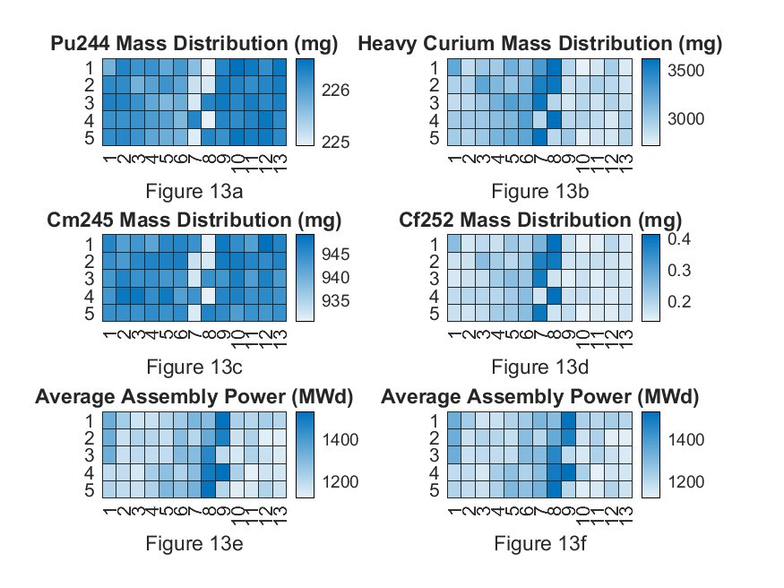

*Figure 13. Heat map of Pu-244, Heavy Curium, Cm-245, and Cf-252. Below the isotope heat maps are heat maps of the average assembly power. Each square represents an assembly but there is no significance in the order of the squares. For assemblies with a low average power, more Pu-244 and Cm-245 was produced. For assemblies with high average power, more Cf-252 and heavy curium was produced.*

This relationship could be explained by the Cf-252 production chain. Upon the creation of Pu-243 (T1/2 = 4.95 hr), beta decay transforms the isotope into Am-243. Continuing down the production chain, the heavy curium isotopes are produced and eventually, Cf-252. Pu-243 does have a thermal neutron cross section (σγ = 9E1 b), creating the Pu-244 isotope. This event significantly reduces the possibility of creating Cf-252 because Pu-244 has an extremely long half life and alpha decays into U-240. In the event the Pu-244 isotope captures a neutron, the decay chain of Pu-245 (T1/2 = 10.5 hr) first decays to Am-245 (T1/2 = 2.05 hr), which decays to Cm-245 (T1/2 = 8500 yr). As such, it was found that assemblies with high inventories of Pu-244 also had high inventories of Cm-245 (figures 13a, 13c).

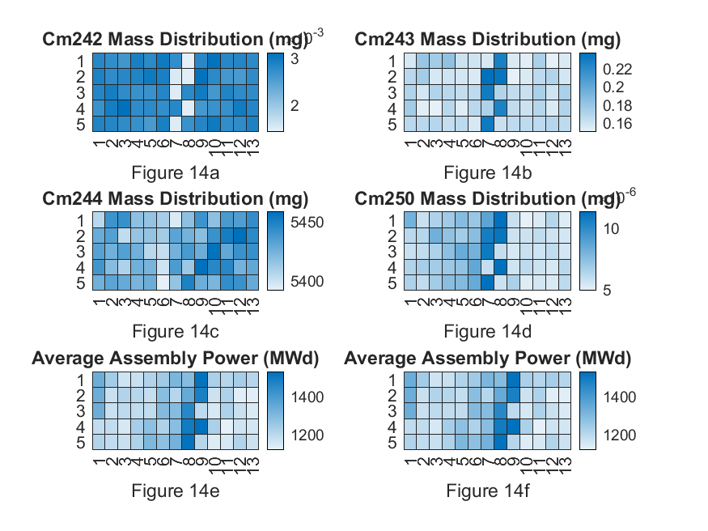

*Figure 14. Heat map of the remaining Cu isotopes (Cm-242, Cm-243, Cm-244, and Cm-250). Below the isotope heat maps are heat maps of the average assembly power. Each square represents an assembly but there is no significance in the order of the squares. For assemblies with a low average power, more Cm-242 was produced. For assemblies with high average power, more Cm-243 and Cm-250 was produced. No clear relationship can be found for the production of Cm-244.*

The heat map of the remaining Cu isotopes is shown above. Cm-243 and Cm-250 appear to follow the same power relationship as Cf-252 and heavy curium. Cm-242 while displaying the same power relationship as Pu-244 and Cm-245, has almost decayed away and is only present in very small quantities. Cm-244 visibly shows no correlation with the reactor power, but is present in the highest quantities among any isotope tracked. Cm-244 has been proposed as an alternative power source for generators.

The relationship between the assembly power and the production of Pu-244 and heavy curium creates the ability to easily compare similar targets by irradiation histories. A target that had been exposed to a higher neutron flux compared to another target could be expected to contain more heavy curium but less Pu-244. While target material and densities can affect the probabilities of certain decay chains and capture events, this project has showcased the ability to relate irradiation history to isotopic production, allowing for faster target comparisons when funding and time is limited.

# Conclusion

From 1969 to 1970, a Cf-252 production campaign was conducted at SRS. Following the processing of 21 assemblies, the remainder of the targets were exposed in the K-reactor and subsequently put into storage after 10 years of irradiation. This study was done to determine the current inventories of key isotopes and investigate the trends in their production. Using SCALE, 65 individual simulations were performed to analyze and estimate the isotopic production and decay in each assembly. An analysis was then conducted on each assembly dataset to determine which assemblies produced the most Cf-252, Pu-244, and heavy curium. It was found that the more Cf-252 an assembly produced, the less Pu-244 and heavy curium was present at the end of simulation. Assembly 46 is calculated to contain the most Pu-244 and heavy curium and assembly 36 and 39 were found to have the least Pu-244 and heavy curium. The results lend to a strategy of tracking one isotope, such as Cf-252, in order to predict which assemblies will contain more Pu-244 or heavy curium, which can significantly reduce computational time and logistical costs associated with processing these Mk-18A targets.

# 

# Acknowledgments

This project is supported by Dr. Tracy Stover and Ms. Tara Smith from the Savannah River National Laboratory and advised by Dr. Benjamin Beeler from North Carolina State University. SCALE was acquired through the Radiation Safety Information Computational Center at ORNL. SCALE computations are completed through the Reactor Dynamics Fuel Modeling Group High Performance Cluster at North Carolina State University.

# 

# Work Cited

1. SHARON ROBINSON & BRAD PATTON, *“Mark-18A Target Materials Recovery Study”,* Oak Ridge National Laboratory, 2015

2. O'NEIL, MARYDALE J.; HECKELMAN, PATRICIA E.; ROMAN, CHERIE B., eds. (2006). The Merck Index: An Encyclopedia of Chemicals, Drugs, and Biologicals (14th ed.). Merck Research Laboratories, Merck & Co. ISBN 978-0-911910-00-1.

3. OSBORNE-LEE, I. W.; ALEXANDER, C. W. (1995). "Californium-252: A Remarkable Versatile Radioisotope". Oak Ridge Technical Report ORNL/TM-12706. doi:10.2172/205871.

4. National Research Council (U.S.). Committee on Radiation Source Use and Replacement (2008). Radiation Source Use and Replacement: Abbreviated Version. National Academies Press. ISBN 978-0-309-11014-3.

5. S. M. Robinson et al., Evaluation of Disposition Options for Mark-18A (Mk-18A) Target Materials, ORNL/TM-2013/148R1, 2014.

6. WADE BICKFORD, “*Estimate of Fission Products in the Mark-18A OH Targets”*, Westinghouse Savannah River Company, 2003

7. DPSTM-18-51-P, Technical Manual Californium Physics, 7/1/69, Savannah River Laboratory, Aiken, SC

8. DPSOP-134, SRP Reactor Assemblies, page 2204, Mark 18A, Savannah River Laboratory, Aiken, SC

9. WILLIAM P. BEBBINGTON, “*History of Du Pont at the Savannah River Plant”*, E. I. du Pont de Nemours and Company, 1990

10. DPSTM-18-51-P, Technical Manual Californium Physics, 7/1/69, Savannah River Laboratory, Aiken, SC

11. DPSOP-134, SRP Reactor Assemblies, page 2204, Mark 18A, Savannah River Laboratory, Aiken, SC

12. Weiselquist, William A. “SCALE Overview.” Oak Ridge National Laboratory, www.ornl.gov/scale/overview.

13. 1. SHARON ROBINSON & BRAD PATTON, *“Mark-18A Target Materials Recovery Study”,* Oak Ridge National Laboratory, 2015

# 

# Appendix A (Core Placement for each cycle x, y)

|  |  |  |  |  |  |  |  |  |  |  |  |  |  |  |  |  |  |  |  |  |
| --- | --- | --- | --- | --- | --- | --- | --- | --- | --- | --- | --- | --- | --- | --- | --- | --- | --- | --- | --- | --- |
|  | Cf-I | | K-1 | | K-2 | | K-3 | | K-4 | | K-5 | | K-6 K-7 K-8 | | K-9 K-10 K-11.1 | | K-11.2-.4 K-12 K-13 K-1.1-.2 | | K-1.3 K-1.4 | |
| 1 | 29 | 57 | 37 | 33 | 37 | 33 | 37 | 33 | 37 | 33 | 14 | 12 | 37 | 33 | 55 | 51 | 55 | 51 | 55 | 51 |
| 2 | 24 | 54 | 16 | 42 | 16 | 42 | 16 | 42 | 16 | 42 | 47 | 75 | 16 | 42 | 1 | 51 | 1 | 51 | 1 | 51 |
| 3 | 27 | 39 | 31 | 69 | 31 | 69 | 31 | 69 | 31 | 69 | 44 | 78 | 31 | 69 | 29 | 3 | 29 | 3 | 29 | 3 |
| 4 | 34 | 60 | 46 | 60 | 46 | 60 | 46 | 60 | 46 | 60 | 19 | 87 | 46 | 60 | 3 | 33 | 3 | 33 | 3 | 33 |
| 5 | 35 | 39 | 34 | 18 | 34 | 18 | 34 | 18 | 34 | 18 | 37 | 9 | 34 | 18 | 53 | 63 | 53 | 63 | 53 | 63 |
| 6 | 38 | 48 | 23 | 15 | 23 | 15 | 23 | 15 | 23 | 15 | 5 | 39 | 25 | 45 | 18 | 90 | 18 | 90 | 18 | 90 |
| 7 | 23 | 63 | 48 | 42 | 48 | 42 | 48 | 42 | 48 | 42 | 21 | 9 | 48 | 42 | 4 | 30 | 4 | 30 | 4 | 30 |
| 8 | 37 | 45 | 13 | 69 | 13 | 69 | 13 | 69 | 13 | 69 | 28 | 90 | 13 | 69 | 52 | 66 | 52 | 66 | 52 | 66 |
| 9 | 19 | 51 | 25 | 15 | 25 | 15 | 25 | 15 | 25 | 15 | 28 | 6 | 25 | 15 | 36 | 90 | 36 | 90 | 36 | 90 |
| 10 | 21 | 57 | 20 | 18 | 20 | 18 | 20 | 18 | 20 | 18 | 22 | 90 | 20 | 18 | 20 | 90 | 20 | 90 | 20 | 90 |
| 11 | 18 | 48 | 15 | 21 | 15 | 21 | 15 | 21 | 15 | 21 | 35 | 87 | 15 | 21 | 4 | 66 | 4 | 66 | 4 | 66 |
| 12 | 22 | 36 | 46 | 36 | 46 | 36 | 46 | 36 | 46 | 36 | 26 | 6 | 46 | 36 | 36 | 6 | 36 | 6 | 36 | 6 |
| 13 | 20 | 42 | 47 | 51 | 47 | 51 | 47 | 51 | 47 | 51 | 52 | 42 | 47 | 51 | 3 | 63 | 3 | 63 | 3 | 63 |
| 14 | 23 | 33 | 21 | 81 | 21 | 81 | 21 | 81 | 21 | 81 | 51 | 63 | 21 | 81 | 20 | 6 | 20 | 6 | 20 | 6 |
| 15 | 31 | 33 | 25 | 81 | 25 | 81 | 25 | 81 | 25 | 81 | 4 | 54 | 25 | 81 | 52 | 30 | 52 | 30 | 52 | 30 |
| 16 | 33 | 33 | 14 | 72 | 14 | 72 | 14 | 72 | 14 | 72 | 52 | 48 | 22 | 72 | 38 | 90 | 38 | 90 | 38 | 90 |
| 17 | 27 | 33 | 17 | 75 | 17 | 75 | 17 | 75 | 17 | 75 | 24 | 90 | 23 | 63 | 33 | 93 | 33 | 93 | 33 | 93 |
| 18 | 29 | 63 | 40 | 72 | 40 | 72 | 40 | 72 | 40 | 72 | 21 | 87 | 40 | 72 | 23 | 3 | 23 | 3 | 23 | 3 |
| 19 | 36 | 54 | 10 | 54 | 10 | 54 | 10 | 54 | 10 | 54 | 26 | 90 | 10 | 54 | 3 | 39 | 3 | 39 | 3 | 39 |
| 20 | 32 | 60 | 30 | 78 | 30 | 78 | 30 | 78 | 30 | 78 | 9 | 21 | 30 | 78 | 54 | 42 | 54 | 42 | 54 | 42 |
| 21 | 26 | 60 | 11 | 45 | 11 | 45 | 11 | 45 | 11 | 45 | 34 | 6 | 11 | 45 | 21 | 93 | 21 | 93 | 21 | 93 |
| 22 | 28 | 60 | 41 | 63 | 6 | 60 | 6 | 60 | 6 | 60 | 52 | 36 | 13 | 39 | 25 | 3 | 25 | 3 | 25 | 3 |
| 23 | 22 | 54 | 31 | 75 | 31 | 75 | 17 | 33 | 17 | 33 | 32 | 6 | 17 | 33 | 2 | 42 | 2 | 42 | 2 | 42 |
| 24 | 34 | 54 | 40 | 30 | 40 | 30 | 26 | 72 | 26 | 72 | 30 | 6 | 26 | 72 | 2 | 60 | 2 | 60 | 2 | 60 |
|  | Cf-I | | K-1 | | K-2 | | K-3 | | K-4 | | K-5 | | K-6 K-7 K-8 | | K-9 K-10 K-11.1 | | K-11.2-.4 K-12 K-13 K-1.1-.2 | | K-1.3 K-1.4 | |
| 25 | 35 | 51 | 18 | 66 | 18 | 66 | 18 | 66 | 18 | 66 | 10 | 18 | 18 | 66 | 2 | 48 | 2 | 48 | 2 | 48 |
| 26 | 32 | 36 | 12 | 36 | 12 | 36 | 12 | 36 | 12 | 36 | 13 | 15 | 12 | 36 | 31 | 3 | 31 | 3 | 31 | 3 |
| 27 | 35 | 45 | 45 | 45 | 45 | 45 | 45 | 45 | 45 | 45 | 51 | 39 | 33 | 27 | 53 | 33 | 53 | 33 | 53 | 33 |
| 28 | 33 | 39 | 42 | 54 | 42 | 54 | 42 | 54 | 42 | 54 | 12 | 18 | 42 | 54 | 54 | 58 | 54 | 58 | 54 | 58 |
| 29 | 36 | 48 | 42 | 30 | 42 | 30 | 42 | 30 | 42 | 30 | 43 | 81 | 42 | 30 | 25 | 93 | 25 | 93 | 25 | 93 |
| 30 | 33 | 57 | 21 | 75 | 21 | 75 | 21 | 75 | 21 | 75 | 5 | 57 | 24 | 54 | 35 | 3 | 35 | 3 | 35 | 3 |
| 31 | 30 | 36 | 18 | 24 | 18 | 24 | 18 | 24 | 18 | 24 | 4 | 60 | 23 | 33 | 53 | 57 | 53 | 57 | 53 | 57 |
| 32 | 23 | 39 | 35 | 75 | 35 | 75 | 35 | 75 | 35 | 75 | 35 | 9 | 35 | 75 | 31 | 93 | 31 | 93 | 31 | 93 |
| 33 | 21 | 45 | 24 | 24 | 24 | 24 | 24 | 24 | 24 | 24 | 46 | 78 | 24 | 24 | 27 | 93 | 27 | 93 | 27 | 93 |
| 34 | 30 | 54 | 38 | 48 | 38 | 48 | 11 | 57 | 11 | 57 | 51 | 33 | 11 | 57 | 33 | 3 | 33 | 3 | 33 | 3 |
| 35 | 26 | 42 | 23 | 33 | 23 | 33 | 14 | 60 | 14 | 60 | 42 | 84 | 14 | 60 | 27 | 3 | 27 | 3 | 27 | 3 |
| 36 | 30 | 42 | 23 | 63 | 23 | 63 | 14 | 30 | 14 | 30 | 16 | 12 | 22 | 24 | 29 | 93 | 29 | 93 | 29 | 93 |
| 37 | 32 | 48 | 20 | 48 | 20 | 48 | 26 | 78 | 26 | 78 | 17 | 87 | 28 | 54 | 54 | 36 | 54 | 36 | 54 | 36 |
| 38 | 29 | 51 | 28 | 54 | 28 | 54 | 41 | 69 | 41 | 69 | 48 | 72 | 41 | 69 | 1 | 45 | 27 | 39 | 1 | 45 |
| 39 | 27 | 51 | 24 | 54 | 24 | 54 | 41 | 63 | 41 | 63 | 39 | 9 | 41 | 63 | 54 | 54 | 33 | 51 | 54 | 54 |
| 40 | 26 | 48 | 25 | 45 | 25 | 45 | 41 | 39 | 41 | 39 | 40 | 84 | 41 | 39 | 23 | 93 | 28 | 54 | 23 | 93 |
| 41 | 27 | 45 | 33 | 51 | 33 | 51 | 29 | 21 | 29 | 21 | 7 | 27 | 29 | 21 | 53 | 39 | 31 | 45 | 53 | 39 |
| 42 | 29 | 45 | 31 | 45 | 31 | 45 | 32 | 18 | 32 | 18 | 8 | 24 | 32 | 18 | 2 | 54 | 25 | 45 | 2 | 54 |
| 43 | 25 | 63 | 13 | 27 | 13 | 27 | 13 | 27 | 13 | 27 | 30 | 90 | 13 | 27 | 38 | 6 | 38 | 6 | 38 | 6 |
| 44 | 30 | 48 | 27 | 39 | 27 | 39 | 27 | 39 | 44 | 36 | 49 | 69 | 43 | 51 | 3 | 57 | 24 | 54 | 3 | 57 |
| 45 | 38 | 54 | 35 | 81 | 35 | 81 | 35 | 81 | 35 | 81 | 4 | 48 | 37 | 57 | 18 | 6 | 18 | 6 | 18 | 6 |
| 46 | 33 | 63 | 47 | 57 | 47 | 57 | 47 | 57 | 47 | 57 | 52 | 54 | 32 | 60 | 40 | 6 | 40 | 6 | 40 | 6 |
| 47 | 36 | 36 | 41 | 21 | 41 | 21 | 41 | 21 | 41 | 21 | 4 | 42 | 43 | 45 | 40 | 90 | 40 | 90 | 40 | 90 |
| 48 | 37 | 57 | 8 | 42 | 8 | 42 | 8 | 42 | 8 | 42 | 53 | 45 | 17 | 75 | 16 | 6 | 16 | 6 | 16 | 6 |
| 49 | 39 | 51 | 28 | 12 | 28 | 12 | 28 | 12 | 28 | 12 | 6 | 30 | 28 | 30 | 5 | 27 | 5 | 27 | 5 | 27 |
|  | Cf-I | | K-1 | | K-2 | | K-3 | | K-4 | | K-5 | | K-6 K-7 K-8 | | K-9 K-10 K-11.1 | | K-11.2-.4 K-12 K-13 K-1.1-.2 | | K-1.3 K-1.4 | |
| 50 | 35 | 63 | 45 | 27 | 45 | 27 | 45 | 27 | 45 | 27 | 3 | 45 | 38 | 24 | 43 | 87 | 43 | 87 | 43 | 87 |
| 51 | 35 | 33 | 10 | 66 | 10 | 66 | 10 | 66 | 10 | 66 | 50 | 66 | 20 | 48 | 41 | 87 | 41 | 87 | 41 | 87 |
| 52 | 39 | 45 | 30 | 84 | 30 | 84 | 30 | 84 | 30 | 84 | 53 | 51 | 31 | 45 | 15 | 9 | 15 | 9 | 15 | 9 |
| 53 | 37 | 39 | 46 | 66 | 46 | 66 | 46 | 66 | 46 | 66 | 39 | 87 | 32 | 36 | 51 | 69 | 51 | 69 | 51 | 69 |
| 54 | 32 | 30 | 9 | 63 | 9 | 63 | 9 | 63 | 9 | 63 | 19 | 9 | 9 | 63 | 44 | 84 | 44 | 84 | 44 | 84 |
| 55 | 24 | 30 | 30 | 12 | 30 | 12 | 30 | 12 | 30 | 12 | 17 | 9 | 30 | 12 | 12 | 12 | 12 | 12 | 12 | 12 |
| 56 | 26 | 30 | 9 | 33 | 9 | 33 | 9 | 33 | 9 | 33 | 3 | 51 | 19 | 57 | 6 | 24 | 6 | 24 | 6 | 24 |
| 57 | 28 | 30 | 45 | 69 | 45 | 69 | 45 | 69 | 45 | 69 | 5 | 33 | 45 | 69 | 50 | 72 | 50 | 72 | 50 | 72 |
| 58 | 18 | 42 | 40 | 78 | 40 | 78 | 40 | 78 | 40 | 78 | 51 | 57 | 40 | 30 | 7 | 21 | 7 | 21 | 7 | 21 |
| 59 | 21 | 33 | 10 | 24 | 10 | 24 | 10 | 24 | 10 | 24 | 37 | 87 | 19 | 27 | 8 | 18 | 8 | 18 | 8 | 18 |
| 60 | 17 | 45 | 7 | 51 | 7 | 51 | 7 | 51 | 7 | 51 | 24 | 6 | 15 | 51 | 11 | 15 | 11 | 15 | 11 | 15 |
| 61 | 19 | 39 | 37 | 15 | 37 | 15 | 37 | 15 | 37 | 15 | 32 | 90 | 38 | 48 | 49 | 75 | 49 | 75 | 49 | 75 |
| 62 | 19 | 57 | 33 | 9 | 33 | 9 | 33 | 9 | 33 | 9 | 22 | 6 | 36 | 66 | 47 | 81 | 47 | 81 | 47 | 81 |
| 63 | 20 | 60 | 49 | 33 | 49 | 33 | 49 | 33 | 49 | 33 | 4 | 36 | 31 | 75 | 45 | 81 | 45 | 81 | 45 | 81 |
| 64 | 21 | 63 | 25 | 87 | 25 | 87 | 25 | 87 | 25 | 87 | 52 | 60 | 27 | 39 | 48 | 78 | 48 | 78 | 48 | 78 |
| 65 | 17 | 51 | 45 | 75 | 45 | 75 | 45 | 75 | 45 | 75 | 34 | 90 | 33 | 51 | 9 | 15 | 9 | 15 | 9 | 15 |

# 

# Appendix B (Irradiation History)

|  |  |  |  |  |
| --- | --- | --- | --- | --- |
| **Cycle** | **Days** | **MW-Days cumulative by Cycle** | **Driver Fuel Type** | **Day shut down between cycles** |
| K1-K94 | 455 | 446,161 | MK-18 | 124 |
| K1.1 | 56 | 80,992 | Mk-14 | 3 |
| K1.2 | 37 | 59,774 | Mk-14 | 4 |
| K1.3 | 35 | 58,421 | Mk-14 | 11 |
| K2.1 | 52 | 75,703 | Mk-14 | 4 |
| K2.2 | 31 | 53,314 | Mk-14 | 3 |
| K2.3 | 20 | 30,399 | Mk-14 | 10 |
| K3.1 | 45 | 70,490 | Mk-14 | 2 |
| K3.2 | 26 | 48,326 | Mk-14 | 3 |
| K3.3 | 36 | 44,025 | Mk-14 | 4 |
| K4.1 | 43 | 72,006 | Mk-14 | 3 |
| K4.2 | 31 | 52,867 | Mk-14 | 2 |
| K4.3 | 25 | 35,279 | Mk-14 | 23 |
| K-5 | 143 | 259,154 | Mk-22 | 11 |
| K6.1 | 40 | 79,392 | Mk-14 | 3 |
| K6.2 | 24 | 50,087 | Mk-14 | 19 |
| K7.1 | 67 | 111,765 | Mk-16 | 4 |
| K7.2 | 60 | 102,359 | Mk-16 | 3 |
| K7.3 | 68 | 106,222 | Mk-16 | 7 |
| K8.1 | 64 | 114,127 | Mk-16 | 5 |
| K8.2 | 53 | 103,782 | Mk-16 | 4 |
| K8.3 | 50 | 91,106 | Mk-16 | 20 |
| K-9.1 | 151 | 268,280 | Mk-22 | 22 |
| K9.2 | 106 | 193,897 | Mk-22 | 5 |
| K9.3 | 51 | 83,669 | Mk-22 | 33 |
| **Cycle** | **Days** | **MW-Days cumulative by Cycle** | **Driver Fuel Type** | **Day shut down between cycles** |
| K10.1 | 73 | 103,460 | Mk-16 | 5 |
| K10.2 | 87 | 118,892 | Mk-16 | 9 |
| K10.3 | 55 | 84,406 | Mk-16 | 7 |
| K10.4 | 50 | 79,674 | Mk-16 | 18 |
| K11.1 | 60 | 106,751 | Mk-16 | 9 |
| K11.2 | 69 | 112,107 | Mk-16 | 6 |
| K11.3 | 51 | 86,529 | Mk-16 | 7 |
| K11.4 | 50 | 74,889 | Mk-16 | 60 |
| K-12.1 | 54 | 98,377 | Mk-16 | 8 |
| K-12.2 | 63 | 107,680 | Mk-16 | 6 |
| K-12.3 | 66 | 87,409 | Mk-16 | 6 |
| K-12.4 | 50 | 80,214 | Mk-16 | 91 |
| K-13.1 | 58 | 97,428 | Mk-16 | 8 |
| K-13.2 | 62 | 114,244 | Mk-16 | 12 |
| K-13.3 | 58 | 96,855 | Mk-16 | 11 |
| K-13.4 | 60 | 82,000 | Mk-16 | 26 |
| K-1.1 | 54 | 99,497 | Mk-16 | 49 |
| K-1.2 | 55 | 100,674 | Mk-16 | 11 |
| K-1.3 | 58 | 107,780 | Mk-16 | 10 |
| K-1.4 | 50 | 87,166 | Mk-16 | N/A |

# 

# 

# 

# 

# 

# Appendix C (Cumulative Results Projection for January 1, 2025 [g])

|  |  |  |  |  |  |  |  |  |  |  |
| --- | --- | --- | --- | --- | --- | --- | --- | --- | --- | --- |
|  | Cf-252 | Pu-244 | Cm-242 | Cm-243 | Cm-244 | Cm-245 | Cm-246 | Cm-247 | Cm-248 | Cm-250 |
| 1 | 2.19E-07 | 6.45E-02 | 2.95E-13 | 5.23E-10 | 8.78E-05 | 4.80E-04 | 1.30E+00 | 5.61E-02 | 5.32E-01 | 1.20E-06 |
| 2 | 3.40E-09 | 2.26E-01 | 2.89E-06 | 1.67E-04 | 5.43E+00 | 9.45E-01 | 2.81E+00 | 7.46E-02 | 3.47E-02 | 6.17E-09 |
| 3 | 3.24E-09 | 2.26E-01 | 2.85E-06 | 1.70E-04 | 5.43E+00 | 9.43E-01 | 2.75E+00 | 7.24E-02 | 3.31E-02 | 5.74E-09 |
| 4 | 3.77E-09 | 2.26E-01 | 2.68E-06 | 1.75E-04 | 5.44E+00 | 9.44E-01 | 2.87E+00 | 7.68E-02 | 3.64E-02 | 6.39E-09 |
| 5 | 3.54E-09 | 2.26E-01 | 2.88E-06 | 1.67E-04 | 5.43E+00 | 9.45E-01 | 2.85E+00 | 7.61E-02 | 3.58E-02 | 6.44E-09 |
| 6 | 3.37E-09 | 2.26E-01 | 2.73E-06 | 1.79E-04 | 5.44E+00 | 9.42E-01 | 2.76E+00 | 7.27E-02 | 3.34E-02 | 5.83E-09 |
| 7 | 3.54E-09 | 2.26E-01 | 2.77E-06 | 1.75E-04 | 5.43E+00 | 9.43E-01 | 2.82E+00 | 7.50E-02 | 3.50E-02 | 6.24E-09 |
| 8 | 3.21E-09 | 2.26E-01 | 2.96E-06 | 1.58E-04 | 5.43E+00 | 9.46E-01 | 2.78E+00 | 7.32E-02 | 3.37E-02 | 5.95E-09 |
| 9 | 3.49E-09 | 2.26E-01 | 2.96E-06 | 1.52E-04 | 5.42E+00 | 9.48E-01 | 2.88E+00 | 7.68E-02 | 3.63E-02 | 6.70E-09 |
| 10 | 3.39E-09 | 2.26E-01 | 2.86E-06 | 1.67E-04 | 5.43E+00 | 9.45E-01 | 2.80E+00 | 7.42E-02 | 3.44E-02 | 6.02E-09 |
| 11 | 3.88E-09 | 2.26E-01 | 2.63E-06 | 1.76E-04 | 5.44E+00 | 9.44E-01 | 2.89E+00 | 7.75E-02 | 3.69E-02 | 6.43E-09 |
| 12 | 4.45E-09 | 2.26E-01 | 2.83E-06 | 1.56E-04 | 5.40E+00 | 9.46E-01 | 3.11E+00 | 8.56E-02 | 4.31E-02 | 8.12E-09 |
| 13 | 3.73E-09 | 2.26E-01 | 2.76E-06 | 1.71E-04 | 5.43E+00 | 9.44E-01 | 2.88E+00 | 7.71E-02 | 3.66E-02 | 6.47E-09 |
| 14 | 3.39E-09 | 2.26E-01 | 3.13E-06 | 1.51E-04 | 5.41E+00 | 9.48E-01 | 2.88E+00 | 7.68E-02 | 3.63E-02 | 6.76E-09 |
| 15 | 3.75E-09 | 2.26E-01 | 2.77E-06 | 1.69E-04 | 5.43E+00 | 9.44E-01 | 2.89E+00 | 7.76E-02 | 3.69E-02 | 6.77E-09 |
| 16 | 3.62E-09 | 2.26E-01 | 2.94E-06 | 1.82E-04 | 5.42E+00 | 9.41E-01 | 2.88E+00 | 7.69E-02 | 3.63E-02 | 6.88E-09 |
| 17 | 4.00E-09 | 2.26E-01 | 2.87E-06 | 1.59E-04 | 5.42E+00 | 9.46E-01 | 3.00E+00 | 8.13E-02 | 3.97E-02 | 7.29E-09 |
| 18 | 4.34E-09 | 2.26E-01 | 2.67E-06 | 1.67E-04 | 5.42E+00 | 9.45E-01 | 3.03E+00 | 8.27E-02 | 4.09E-02 | 7.37E-09 |
| 19 | 3.97E-09 | 2.26E-01 | 2.77E-06 | 1.67E-04 | 5.43E+00 | 9.45E-01 | 2.96E+00 | 7.99E-02 | 3.86E-02 | 6.99E-09 |
| 20 | 4.27E-09 | 2.26E-01 | 2.71E-06 | 1.63E-04 | 5.42E+00 | 9.45E-01 | 3.03E+00 | 8.25E-02 | 4.07E-02 | 7.42E-09 |
| 21 | 4.23E-09 | 2.26E-01 | 2.81E-06 | 1.60E-04 | 5.41E+00 | 9.46E-01 | 3.04E+00 | 8.29E-02 | 4.10E-02 | 7.53E-09 |
| 22 | 3.56E-09 | 2.26E-01 | 2.99E-06 | 1.58E-04 | 5.42E+00 | 9.47E-01 | 2.90E+00 | 7.76E-02 | 3.68E-02 | 6.77E-09 |
| 23 | 4.77E-09 | 2.26E-01 | 2.69E-06 | 1.63E-04 | 5.40E+00 | 9.43E-01 | 3.15E+00 | 8.71E-02 | 4.43E-02 | 8.34E-09 |
| 24 | 4.05E-09 | 2.26E-01 | 2.79E-06 | 1.54E-04 | 5.42E+00 | 9.48E-01 | 2.99E+00 | 8.12E-02 | 3.97E-02 | 7.28E-09 |
| 25 | 4.60E-09 | 2.26E-01 | 2.58E-06 | 1.66E-04 | 5.43E+00 | 9.44E-01 | 3.07E+00 | 8.44E-02 | 4.22E-02 | 7.70E-09 |
|  | Cf-252 | Pu-244 | Cm-242 | Cm-243 | Cm-244 | Cm-245 | Cm-246 | Cm-247 | Cm-248 | Cm-250 |
| 26 | 3.65E-09 | 2.26E-01 | 3.01E-06 | 1.59E-04 | 5.41E+00 | 9.46E-01 | 2.93E+00 | 7.87E-02 | 3.76E-02 | 7.10E-09 |
| 27 | 4.01E-09 | 2.26E-01 | 2.92E-06 | 1.56E-04 | 5.41E+00 | 9.47E-01 | 3.01E+00 | 8.18E-02 | 4.01E-02 | 7.44E-09 |
| 28 | 4.38E-09 | 2.26E-01 | 2.85E-06 | 1.66E-04 | 5.40E+00 | 9.44E-01 | 3.09E+00 | 8.47E-02 | 4.23E-02 | 8.07E-09 |
| 29 | 4.77E-09 | 2.26E-01 | 2.73E-06 | 1.67E-04 | 5.40E+00 | 9.42E-01 | 3.16E+00 | 8.74E-02 | 4.45E-02 | 8.52E-09 |
| 30 | 4.38E-09 | 2.26E-01 | 2.93E-06 | 1.57E-04 | 5.39E+00 | 9.45E-01 | 3.12E+00 | 8.58E-02 | 4.32E-02 | 8.41E-09 |
| 31 | 4.84E-09 | 2.26E-01 | 2.73E-06 | 1.56E-04 | 5.40E+00 | 9.44E-01 | 3.19E+00 | 8.85E-02 | 4.55E-02 | 8.76E-09 |
| 32 | 7.84E-09 | 2.25E-01 | 1.51E-06 | 2.38E-04 | 5.43E+00 | 9.33E-01 | 3.37E+00 | 9.65E-02 | 5.28E-02 | 1.06E-08 |
| 33 | 8.18E-09 | 2.25E-01 | 1.48E-06 | 2.30E-04 | 5.42E+00 | 9.32E-01 | 3.41E+00 | 9.82E-02 | 5.44E-02 | 1.09E-08 |
| 34 | 3.38E-09 | 2.26E-01 | 2.81E-06 | 1.71E-04 | 5.44E+00 | 9.44E-01 | 2.79E+00 | 7.37E-02 | 3.41E-02 | 5.91E-09 |
| 35 | 8.30E-09 | 2.25E-01 | 1.49E-06 | 2.31E-04 | 5.42E+00 | 9.31E-01 | 3.44E+00 | 9.92E-02 | 5.53E-02 | 1.12E-08 |
| 36 | 8.65E-09 | 2.25E-01 | 1.42E-06 | 2.28E-04 | 5.42E+00 | 9.30E-01 | 3.46E+00 | 1.00E-01 | 5.62E-02 | 1.13E-08 |
| 37 | 8.24E-09 | 2.25E-01 | 1.46E-06 | 2.34E-04 | 5.42E+00 | 9.32E-01 | 3.41E+00 | 9.83E-02 | 5.44E-02 | 1.10E-08 |
| 38 | 3.38E-09 | 2.26E-01 | 2.80E-06 | 1.70E-04 | 5.44E+00 | 9.44E-01 | 2.79E+00 | 7.37E-02 | 3.41E-02 | 5.86E-09 |
| 39 | 8.57E-09 | 2.25E-01 | 1.46E-06 | 2.26E-04 | 5.41E+00 | 9.30E-01 | 3.46E+00 | 1.00E-01 | 5.62E-02 | 1.12E-08 |
| 40 | 3.41E-09 | 2.26E-01 | 2.69E-06 | 1.62E-04 | 5.45E+00 | 9.46E-01 | 2.78E+00 | 7.34E-02 | 3.39E-02 | 5.70E-09 |
| 41 | 3.35E-09 | 2.26E-01 | 2.81E-06 | 1.55E-04 | 5.44E+00 | 9.48E-01 | 2.79E+00 | 7.38E-02 | 3.42E-02 | 5.82E-09 |
| 42 | 2.96E-09 | 2.26E-01 | 3.09E-06 | 1.50E-04 | 5.42E+00 | 9.47E-01 | 2.73E+00 | 7.14E-02 | 3.24E-02 | 5.69E-09 |
| 43 | 2.96E-09 | 2.26E-01 | 2.97E-06 | 1.64E-04 | 5.43E+00 | 9.44E-01 | 2.69E+00 | 7.00E-02 | 3.14E-02 | 5.37E-09 |
| 44 | 3.51E-09 | 2.26E-01 | 2.60E-06 | 1.65E-04 | 5.46E+00 | 9.46E-01 | 2.78E+00 | 7.36E-02 | 3.41E-02 | 5.62E-09 |
| 45 | 3.64E-09 | 2.26E-01 | 2.86E-06 | 1.66E-04 | 5.43E+00 | 9.45E-01 | 2.88E+00 | 7.71E-02 | 3.65E-02 | 6.55E-09 |
| 46 | 2.65E-09 | 2.27E-01 | 3.09E-06 | 1.53E-04 | 5.42E+00 | 9.45E-01 | 2.61E+00 | 6.73E-02 | 2.96E-02 | 4.94E-09 |
| 47 | 3.27E-09 | 2.26E-01 | 2.80E-06 | 1.56E-04 | 5.44E+00 | 9.47E-01 | 2.76E+00 | 7.28E-02 | 3.35E-02 | 5.70E-09 |
| 48 | 3.51E-09 | 2.26E-01 | 2.61E-06 | 1.62E-04 | 5.46E+00 | 9.47E-01 | 2.79E+00 | 7.38E-02 | 3.42E-02 | 5.75E-09 |
| 49 | 3.56E-09 | 2.26E-01 | 2.69E-06 | 1.61E-04 | 5.45E+00 | 9.47E-01 | 2.82E+00 | 7.51E-02 | 3.51E-02 | 6.07E-09 |
| 50 | 2.83E-09 | 2.27E-01 | 3.00E-06 | 1.66E-04 | 5.42E+00 | 9.42E-01 | 2.65E+00 | 6.86E-02 | 3.05E-02 | 5.23E-09 |
| 51 | 3.08E-09 | 2.26E-01 | 2.81E-06 | 1.73E-04 | 5.44E+00 | 9.42E-01 | 2.69E+00 | 7.01E-02 | 3.16E-02 | 5.32E-09 |
|  | Cf-252 | Pu-244 | Cm-242 | Cm-243 | Cm-244 | Cm-245 | Cm-246 | Cm-247 | Cm-248 | Cm-250 |
| 52 | 3.66E-09 | 2.26E-01 | 2.62E-06 | 1.66E-04 | 5.45E+00 | 9.46E-01 | 2.83E+00 | 7.54E-02 | 3.54E-02 | 6.01E-09 |
| 53 | 3.09E-09 | 2.26E-01 | 2.88E-06 | 1.72E-04 | 5.43E+00 | 9.42E-01 | 2.71E+00 | 7.08E-02 | 3.20E-02 | 5.58E-09 |
| 54 | 3.37E-09 | 2.26E-01 | 2.70E-06 | 1.69E-04 | 5.45E+00 | 9.44E-01 | 2.76E+00 | 7.28E-02 | 3.35E-02 | 5.69E-09 |
| 55 | 3.17E-09 | 2.26E-01 | 2.75E-06 | 1.67E-04 | 5.44E+00 | 9.44E-01 | 2.71E+00 | 7.10E-02 | 3.22E-02 | 5.45E-09 |
| 56 | 3.51E-09 | 2.26E-01 | 2.84E-06 | 1.51E-04 | 5.44E+00 | 9.49E-01 | 2.85E+00 | 7.60E-02 | 3.58E-02 | 6.26E-09 |
| 57 | 3.52E-09 | 2.26E-01 | 2.57E-06 | 1.70E-04 | 5.46E+00 | 9.45E-01 | 2.78E+00 | 7.34E-02 | 3.40E-02 | 5.61E-09 |
| 58 | 3.43E-09 | 2.26E-01 | 2.77E-06 | 1.60E-04 | 5.44E+00 | 9.47E-01 | 2.80E+00 | 7.43E-02 | 3.45E-02 | 5.98E-09 |
| 59 | 2.87E-09 | 2.27E-01 | 2.98E-06 | 1.56E-04 | 5.42E+00 | 9.45E-01 | 2.67E+00 | 6.94E-02 | 3.10E-02 | 5.40E-09 |
| 60 | 3.06E-09 | 2.26E-01 | 2.78E-06 | 1.68E-04 | 5.44E+00 | 9.43E-01 | 2.68E+00 | 6.99E-02 | 3.14E-02 | 5.27E-09 |
| 61 | 2.95E-09 | 2.27E-01 | 2.80E-06 | 1.55E-04 | 5.44E+00 | 9.46E-01 | 2.66E+00 | 6.91E-02 | 3.09E-02 | 5.18E-09 |
| 62 | 3.12E-09 | 2.26E-01 | 2.75E-06 | 1.58E-04 | 5.45E+00 | 9.46E-01 | 2.70E+00 | 7.07E-02 | 3.20E-02 | 5.45E-09 |
| 63 | 3.25E-09 | 2.26E-01 | 2.75E-06 | 1.73E-04 | 5.44E+00 | 9.43E-01 | 2.73E+00 | 7.17E-02 | 3.26E-02 | 5.47E-09 |
| 64 | 3.42E-09 | 2.26E-01 | 2.85E-06 | 1.71E-04 | 5.43E+00 | 9.44E-01 | 2.81E+00 | 7.44E-02 | 3.46E-02 | 6.16E-09 |
| 65 | 3.38E-09 | 2.26E-01 | 2.89E-06 | 1.67E-04 | 5.43E+00 | 9.45E-01 | 2.81E+00 | 7.44E-02 | 3.45E-02 | 6.10E-09 |